Lab 8: Pulse measurement with light – Oximeter

ISIM Fall 2019

Lilo Heinrich

**Voltage Offset**

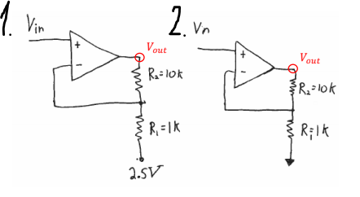

The gain of both circuits is the same, but Circuit 1 has a 2.5V minimum while Circuit 2 has a 0V minimum. If a 1V input was wired to Circuit 1, it would not function because current cannot go backwards through an op amp, and that would be the only way for the output and input voltage to become equal in this negative feedback loop. Choosing the minimum input voltage of a circuit can be useful.

**Circuit Diagram**

Measuring Pulse with Photodiode

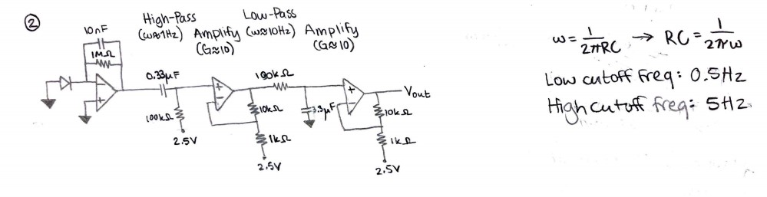

This diagram shows a circuit that reads a photodiode, filters out noise that is outside the range of a heartbeat, and amplifies the signal about a hundred-fold. The calculations of the cutoff frequencies as well as the circuit including the resistor and capacitor values are detailed.

**Circuit Picture**

Picture of my actual circuit. It has minimal loopy wires but is slightly crowded. Analog discovery disconnected to not obscure the circuit.

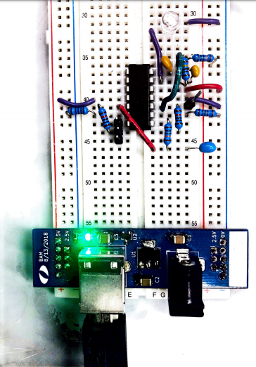

**Circuit Output**

Here is a clean trace of my pulse using this circuit:

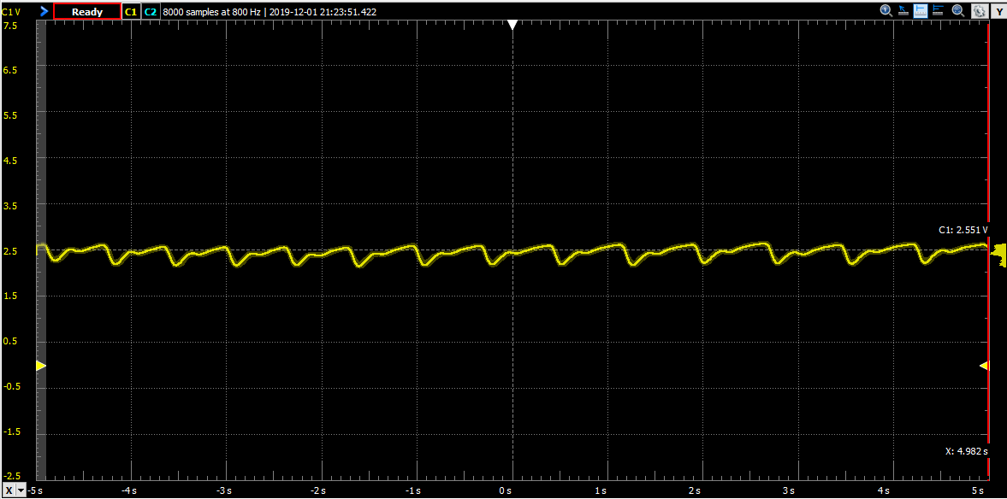

Obviously, the graph is showing a pulse approximately twice every second, perfectly normal for a heartbeat. This signal looks correct, going by face validity.